

DESIGN AND ANALYSIS OF ALGORITHMS (BCE204L)

DIGITAL ASSIGNMENT 2 & 3

OBSERVO:

MONITORING STUDENT BEHAVIOUR PATTERNS USING LOCAL BINARY PATTERN FACE DETECTION ALGORITHMS AND RECOMMENDING TEACHING STRATEGIES BASED ON FITTED LEARNING STYLES

Rishaan Jacob Kuriakose (21BPS1394)

Sanchit Raj (21BRS1621)

**ABSTRACT**

*What the current generation of student’s need is not learning by rote, but rather an upliftment of their mental attitude towards their learning desires and motivation of their passions.*

It is not uncommon to see students lose their attention in class. This lack of attention span is an issue, but this does not indicate lack of potential in students. The above realization provoked to develop a revolutionary product to improve the conditions in the classroom and by helping provide students the best gift of life, education.

Hence, the primary aim is to improve the progress of students attending schools, also attempts to encourage people to send their children to schools, ensuring that they excel in their school life. Also, the product, along with helping teachers, has to be relied upon by learners.

This project presents Observo, an ever-supporting classroom companion. It fits best into the educational industry, enhancing the pupil’s mental response towards lectures and studies.

The project endeavours to explore and seek a solution to the question of how face detection can be utilized to gauge attention in a classroom. The findings of this study could potentially advance research on employing face detection to equip educators with resources that enhance learning in lecture settings.

This research aims to overcome the challenges faced in modern schooling such as poor attendance rates among disabled and differentially abled children and increased number of dropouts, with the usage of an efficient database and other analytic factors based on the fifth generation of computer technology, artificial intelligence.

The usage of a system consisting of a thermal camera and computers connected by a complex network, supported with complex programming, to help students (primarily adolescents) with dyslexia or poor anger-management, is proposed.

TABLE OF CONTENTS

Topic……………………………………………………………………….Page

Abstract...............................................................................................................1

Introduction…………………………................................................................3

Theoretical Background……..............................................................................8

Methodology.....................................................................................................19

Results & Discussions.......................................................................................29

Conclusion……………....................................................................................33

References........................................................................................................34

INTRODUCTION

Problem Statement:

The majority of teachers deal with students' wandering attention on a regular basis. They are frequently spotted dozing off, napping, looking away from the front of the room, texting, or working on assignments for other classes. It's an issue, and instructors frequently find it difficult to not take it personally. It was discovered that 80% of the pupils in the classroom were not paying attention, and a sizable portion of these individuals had dyslexia or poor anger-management.

As education is considered to be the most essential human right, current efforts to increase and improve the number of students attending schools are, at best, acceptable. To pique viewers' attention, educational start-ups, awareness campaigns, workshops, and exhibitions are being held all over the world in relation to education and certain subjects. Even the development of technology, the digitalization of education, and the availability of online tutors today have lowered the strain on the students and helped them comprehend the ideas. Even still, the rate of progress is insufficient. In addition, it is important to monitor the academic and co-curricular development of students who are enrolled in schools. School dropouts are becoming more and more common. Few children who are handicapped or have various levels of ability attend school because their guardians are concerned about their performance and safety in public settings.

It was required to do research on the numerous situations that students encountered in lectures. It starts off with a few particular queries. How many pupils in a class are not paying attention at any one time? How long do these breaks last? How many occur throughout each class period? When throughout the class hour are students' thoughts more prone to wander? Do some teaching techniques correspond to more or less attentiveness? Is it possible, using the face detection techniques of today, to measure the attention of students during a lecture in order to help the teacher improve the lectures?

A study of inattention carried out in three separate chemistry classes addressed all of these issues. Students in those classes utilised clickers to self-report attention lapses to the study team rather than the course instructor. Students used clickers to mark each delay after each lapse by pressing one of three buttons: one for lapses of one minute or less, another for lapses of two to three minutes, and a third button for lapses of five minutes or more.

Only after realising their focus had strayed did students report lapses in attention. Because of this, the student data gathered for this study only includes the moments just after attention gaps, not the lapses themselves. The results of this study reveal that, contrary to popular opinion, students do not listen attentively throughout the whole 10–20 minutes of a lecture. Instead, during the lecture section, their attention shifts in ever-shorter cycles between being interested and not engaged.

The majority of students substantially more frequently reported brief lapses (one minute or less) than medium-or-longer-length lapses. Were they embarrassed and unwilling to accept that they had been absent from their minds for lengthier lengths of time? Or were they attempting to reengage after realising their thoughts had strayed? These are concerns that need further investigation.

When professors used "non-lecture related themes and concepts," such as things like demonstrations, group work, and clicker questions, students consistently reported fewer lapses. This outcome supports previous research showing that when students are involved in activities other than instructor lectures, they are more focused and engaged. The statistics demonstrating that there are noticeably fewer attention lapses during lecture parts immediately after a demonstration or clicker question are equally noteworthy. Students seem to be reinvigorated by the tempo shift and the opportunity for exercise, which makes it simpler for them to pay more attention when the lecture continues. It was also observed that when lecturers used audio and visual aids into their lectures, students tended to respond to questions following lectures with greater assurance and sophistication.

The research's evident teaching implications are that a range of instructional techniques, particularly those that actively engage students, can increase students' attention spans. The topic may be presented to students in a variety of ways through these exercises, which also help them focus when the activity is over. But how can a teacher tell when a certain pupil is paying attention and when he or she isn't? It is important to keep in mind that a teacher may enrol classes of 20–50 pupils. While it is true that experience tends to make it simpler to comprehend students' general behaviour, there are numerous instances in which pupils struggle to grasp the ideas that even experienced teachers attempt to teach.

Aims:

Research was therefore initiated with the following aims in mind:

➢ Research on reasons for lack of attention paid by students in general and specific scenarios.

➢ Research on ways it affects the students' learning processes.

➢ Find an optimal solution that can solve the issue of or compensate for the students' lack of attention in classes.

Competitive Analysis:

While figuring out Observo’s purpose and design, research was directed extensively on existing systems and products that are intended to help the cause. The products enlisted below seemed to highlight the same issues mentioned above but weren’t analogous to the proposed product or weren’t notable competitors in the market, as they differ in terms of means of addressing the problem, cost, materials used, and so on and so forth.

1.Interactive White Boards (IWB)

Interactive White Boards indicate positive effects on students with special educational needs and promote a multi-sensory style of learning. IWB offers a tangible interface which is directed to improve the learning capacities of Special Educational Needs’ children, although their arrangement within the classroom setting in the teacher’s ‘territory’, impacts negatively

on the children as users.

Interactive Whiteboard’s implementation is used for low academic instructions and limited uses, mainly for review games and teacherled interactive websites. Thus, teachers think that professional development is needed to broaden their instructional uses with the IWBs and derive more in-depth use of them.

2.Flipped Classroom

Flipped learning is a pedagogical strategy in which the traditional idea of classroom-based learning is turned upside down. Instead of having students learn the subject in class, they are first exposed to it outside of class via peer discussions and teacher-led problem-solving activities.

This concept enables the student to grasp the concept easier in class and gives him/her more time to go for extended learning and extra problems and additional sources. But again, this might not be associated with the likes of the teacher, due to difference in various values and points in the teacher’s material and the sources referred to by the student and can lead to a disruptive relationship between the 2 ends concerned. And also, the risk in letting the students to take on the conceptual part of the subject on their own, despite in a homely environment with/without the presence of the guardians must not be overlooked.

3. Media:Scape LearnLab™

The LearnLab™ integrates furniture, technology and work tools to support a variety of teaching and learning methods, with placement of screens triangulating sightlines and giving equal access to content. With no front or back of the room, all students can stay engaged.

Face-to-face seating encourages engagement and team collaboration. Display screens and fixed and movable whiteboards offer information permanence and enable students to create, record, and share their work. However, students can tend to misuse this abundance of technology and deviate their attention from the core content of the subject.

Once reviewing the products, Observo was fine-tuned to deal with the flaws mentioned in the competing products, and was backed up with new innovations to allow for the best optimal performance and marketability. The device highlights on incorporating the benefits of technical advancements in education and consists of a thermal camera used to detect movements of students in classes and help in analysis of the students’ behaviour in class. Also, due to the simple structure of the device, it can be easily implemented in classrooms and is affordable. In addition to analysis of the student’s movements, analysis of his/her attention spans helps one understand their interests and weaknesses, enabling the provision of teaching strategies suited to the particular child. This will help the teacher in analysing the students' behaviour from a third-person perspective and adapt a new teaching strategy for that particular child. The system ensures that the teacher teaches the student better and at the same time, does not lead to a decrease in employment in the profession. Altogether, this system is indeed useful in schools, and by perceiving the behavioural patterns of students taken under consideration, it will be possible to make them attentive and understand the concepts clearly, thereby helping them excel in their respective subjects.

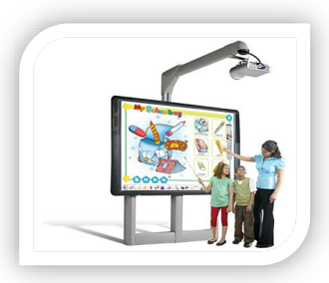 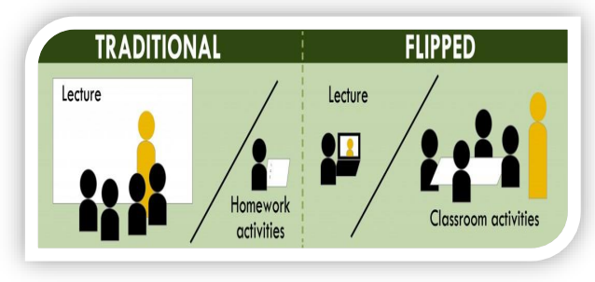

a) IWB b) Flipped Classroom

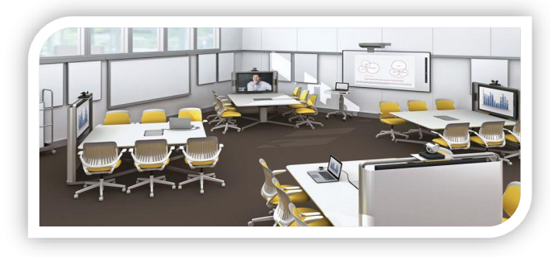

c) Media:Scape LearnLab™

Fig. 1 a), b), c): Existing Competing Products

**THEORETICAL BACKGROUND**

**Background Technology:**

Thermal Cameras

Observo uses thermal image processing, which is an innovative endeavour and one of the product’s highlights. Thermal cameras, when combined with video analytics, have long been considered the best way to detect people's movements. They act like heat vision cameras rather than the ones which use reflected lights. In order to present heat in a format appropriate for human vision, thermal security cameras convert the temperature of objects into shades of grey which are darker or lighter than the background.

❖ Thermographic cameras usually detect radiation in the long-infrared range of the electromagnetic spectrum (roughly 9,000 – 14,000 nanometres or 9 – 14 µm) and produce images of that radiation, called thermo-grams.

❖ Thermal imagery is very rich in data, sensing small temperature variations down to 1/20th of a degree. The camera converts that infrared data into an electronic image that shows the apparent surface temperature of the object being measured. Warmer temperatures can be assigned a shade of red, orange, or yellow, whereas colder temperatures are sometimes given a shade of blue, purple, or green.

❖ Inside of a thermal camera, there are a bunch of tiny measuring devices that capture infrared radiation, called micro-bolometers, and each pixel has one. From there, the micro-bolometer records the temperature and then assigns that pixel to an appropriate colour.

❖ So, in short, the infrared energy is emitted proportionately to the temperature of an object. The infrared energy from the objects is focused by the lens. This energy passes through to the infrared detector, and all this information is passed to the computer for processing as an image.

Some of its distinguishable features are as follows:

✓ Can be used to detect the required movements.

✓ Simple user-interface familiar with laymen.

✓ Safety and Quality of footage.

✓ Comparatively cost-effective for purpose of analysis.

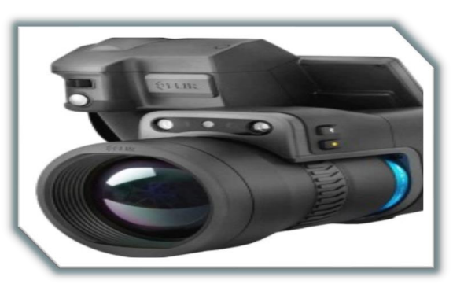

Fig. 2: Thermal Camera

Thermal Image-Processing and Computer Technology

For analysis of data, the thermal images need to be processed. And for that, one of the pre-requisites is the thermal image processing-monitor.

All thermal images are displayed on the test screen. A thermal picture and report of the test portion are produced after each raw steel billet or bar has been processed by the system. Every result is saved and available for download or printing at any time.

A programming software, that, using simple and smart algorithms, provides for the data required to help the teacher understand the students’ personalities, in terms of the background problems faced by the students, the foreground attitudes and the teaching strategies that can be implemented exclusively to the particular student for faster progress is proposed.

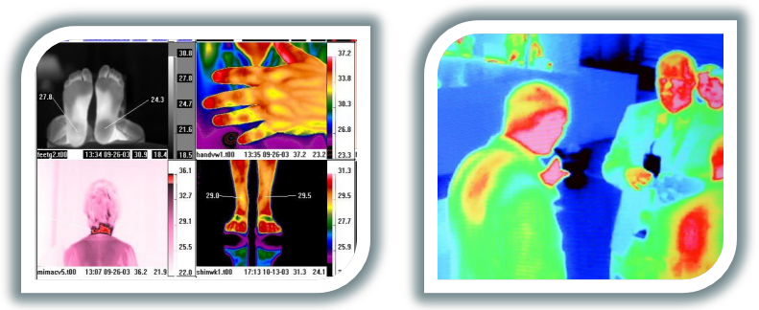

Fig. 3: Images processed by Thermal Camera

NAND Flash Memory

Observo uses NAND flash memory, which is a type of non-volatile storage technology that does not require power to retain data, to store its thermal recordings. In order for flash memory to compete with magnetic storage technologies like hard drives, it has been a priority of NAND flash research to lower the cost per bit and raise maximum chip capacity. NAND flash has found a market in devices to which large files are frequently uploaded and replaced.

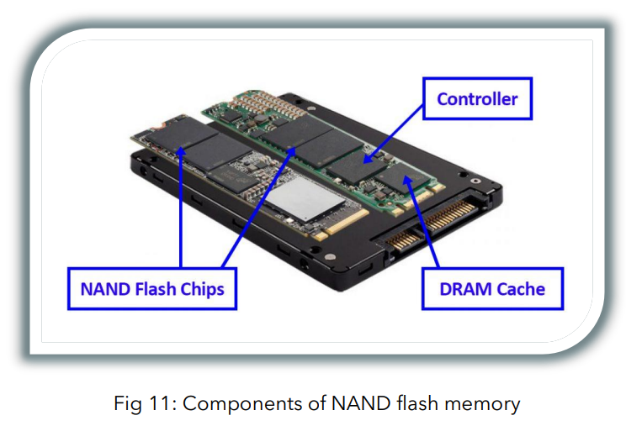

Fig. 4: Components of NAND flash memory

Wi-Fi Networking

One of the many advantages of Observo, is that the thermal cameras also provide for a Wi-Fi connection, allowing the teachers to view the analysed data from any device via the Internet. Wi-Fi's wavebands are best used in line-of-sight because of their relatively high absorption levels. Wi-Fi has improved in spectral efficiency and speed throughout time. As of 2019, at close range, some versions of Wi-Fi running on suitable hardware, can achieve speeds of over 1 Gigabit per second.

**Face Detection Algorithms:**

In their publication [3], Liao and colleagues suggested using a combination of the multi-block local binary pattern (MB-LBP) with the integral image technique and a modified boosting algorithm as an alternative to the Haar-like features employed in the Viola-Jones method, which they found to be too basic and restrictive. Compared to the Haar-like features, the MB-LBP feature set is significantly smaller, resulting in reduced training and classification times. The authors discovered that MB-LBP provides better detection rates (15% and 8% respectively) than both traditional Haar-like features and original LBP features for the same feature set size and has the potential to capture more structural information from an image. Liao et al. utilized the Gentle Adaboost algorithm to select features and construct weak classifiers, as well as a multi-branch regression tree in conjunction with these classifiers.

This thesis provides definitions for technical terms used in the paper.

False Positive   
A false positive occurs when a negative input is incorrectly identified as positive. In the context of this study, false positives refer to faces of individuals who do not meet the definition of paying attention that was used.

Object Class Detection   
Object Class Detection is a computer vision technique that identifies specific objects, such as cars, faces, or other objects, in images or recordings.

Feature Based Detection   
Feature Based Detection is an initial stage of object detection that searches for specific features in the pixels of an image.

Hierarchical Knowledge-Based Method   
Hierarchical Knowledge-Based Method is a knowledge-based approach to face detection that uses rules derived from human face characteristics. The method is hierarchical, with different levels of rules applied to process an image, starting with general descriptions of a face and moving on to specific features.

Face Localization   
Face Localization is the process of identifying the location of a single face within an image.

Texture Analysis   
Texture Analysis involves examining visual patterns within an image, such as color, brightness, randomness, and regularity, to describe the texture properties of the image.

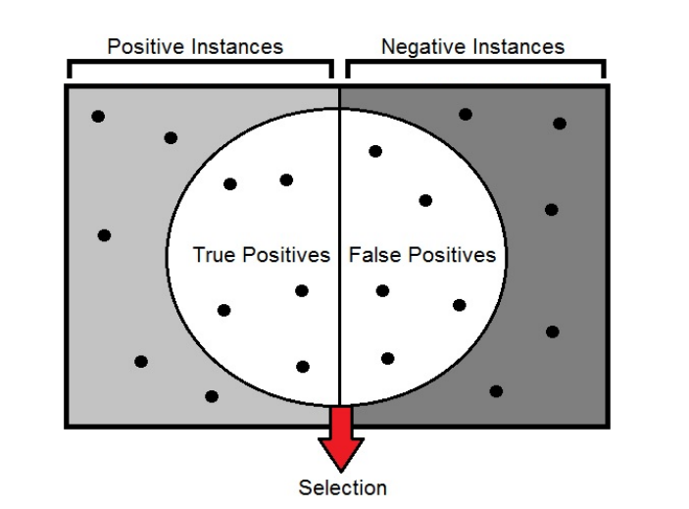

Fig. 5: Visual representation of the relation between selection, positive

and negative instances and true and false positives

**Concept Details:**

Hardware Design

Observo’s components are as follows:

❖ Thermal Camera

❖ NAND Flash memory

❖ LED Monitor

❖ FLIR USB Cable

❖ Processing Equipment

❖ Wi-Fi Networking

The Wi-Fi network provides for an Internet connection, supposing that thermal cameras have to be established at several classes so that information can be passed on radially to the servers allowing for compilation of data.

These cameras are also to be connected to LED Thermal-Image Processing Monitors, at each class, where the visuals can be perceived for thorough analysis. The design of the thermal camera will be similar to that of the FLIR products, allowing for subtle changes with the rendition of algorithmic technology to allow for detection of certain movements of students.They will be placed at the top-most left corner of the side facing the students, so as to perceive the entire class in one frame.

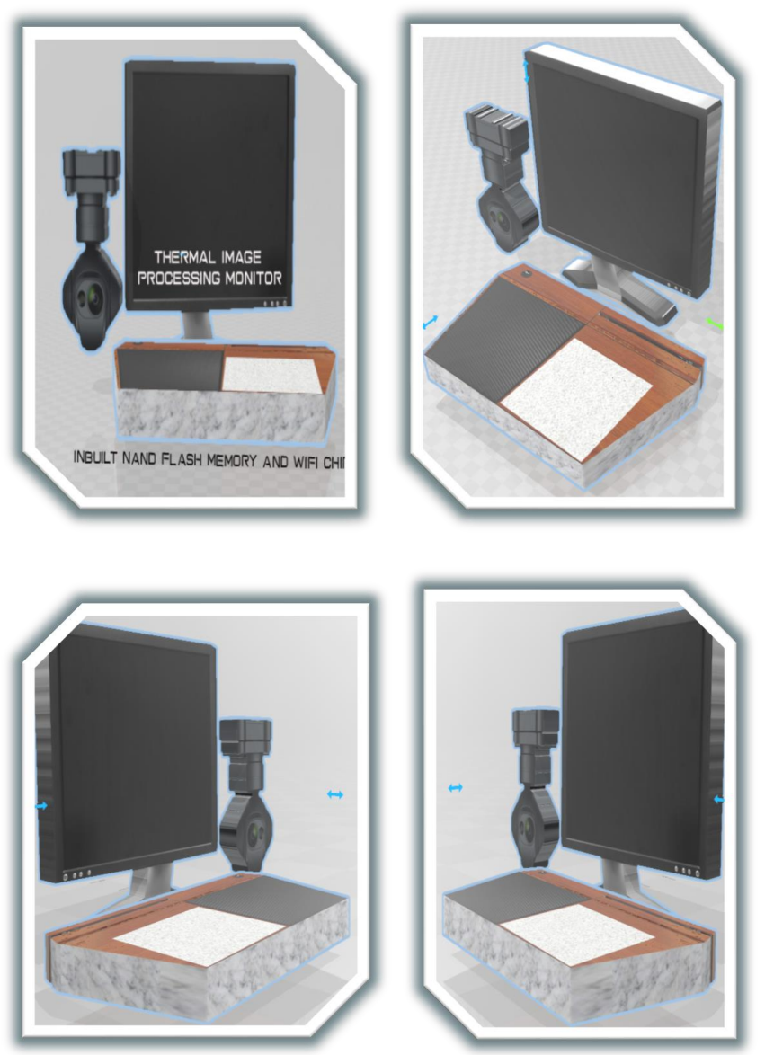

Fig. 6: Graphic Concept Representation

Thermal Cameras

We, as students, do understand that the thought of surveillance might be create a shady atmosphere in the classroom. The students may tend to imitate their actions to try to show a “plastic” or “ideal” behaviour to cover their true intentions. Therefore, the size of the cameras is kept as small as possible, so as to try to not hamper the atmosphere of the classroom. Also, it is planned to finish the cameras with different colours, to match the camera with the paint of the interior walls of the classroom, so that they do not get identified/ distinguished easily by the student or get distracted by them during a lecture. Moreover, these cameras need not be there, throughout the semester. They can be taken away after a week or two from the start of the academic year, as the product will have the data required for analysis by then. They can be put back again for re-analysis after a break to check the students’ behaviour once again, after having adopted the new suggested teaching strategies.

Analysis on Behaviour Patterns

In order for the proper functioning of Observo and to direct it to its purpose, it is of utmost necessity to conduct research on behaviour patterns and attention spans of children and analyse the data. This analysis is crucial for the making of the product as it provides the way for the product’s methods of detecting the movements in children and provide for suggestive ways of teaching suited to each student.

What are the possible causes for challenging behaviour in children?

❖ Health - If a student is experiencing pain or discomfort then they may be acting out to express this, particularly if they have a problem communicating it.

❖ Behavioural difficulties - Conditions like ADHD, autism, and other learning difficulties may make the child unable to handle their feelings effectively. Furthermore, if other children leave them out to these difficulties it’s likely to make their feelings and behaviours worse.

❖ Change - Its worth asking yourself whether the student has been through any big changes recently and whether this is causing them to display challenging behaviour. For example, if they’ve moved to another school, their parents have separated, or someone close to them has passed away.

❖ Learned behaviour - The child may have learnt that acting out is how they get what they want, or may have been in an environment where everyone behaved in the same way. He/she can act irrationally towards the teacher, thereby impacting their relationship and reducing his/her interest in class.

❖ Home environment - If the child has a poor home environment, such as frequent arguing, then he/she may feel like shouting and hostility as a norm. Furthermore, if there are parental problems, such as domestic violence, mental health issues, or drug abuse, the youngster may engage in challenging behaviour as a way to express themselves.

❖ Not Being Challenged Enough - For some children, what is being taught in class isn’t challenging enough. Children who are not sufficiently challenged may get disinterested in the subject matter and cease paying attention completely.

❖ Distracted by External Stimuli - The classroom can be a place full of distractions, from chatty classmates to a cluttered workstation. It can be difficult for some kids than others to block out these distractions, which makes paying attention to the teacher more challenging.

❖ School Anxiety - Another fundamental issue that contributes to lack of attention in the classroom is anxiety over education or grades. Overwhelmed or stressed-out students may just check out, which can result in declining grades and confidence.

❖ Lack in Understanding Material - What can appear to be a lack of focus may actually be a problem with comprehension. This lack of understanding can lead students to stop paying attention and consequently, falling further behind.

❖ Lack of Routine - A lack of routine, often in their home environment, can also create challenging behaviour. For example, not enough sleep and insufficient support. This causes the student to stay duller in class and he/she can tend to sleep during lectures.

There are several behavioural interventions that can help children with attention deficit disorders manage their symptoms of hyperactivity, impulsiveness, and inattention. Some focus on strategies for staying organized and focused. Others aim at cutting down on the disruptive behaviours that can get these children into trouble at school, make it difficult for them to make friends. And turn family life into a combat zone.

An obvious means for young children to receive positive attention from the people who matter most in their life can be a huge motivation. Young children who exhibit the aforementioned behaviours frequently find themselves reprimanded or punished considerably more frequently than they are complimented. It’s not unusual for kids who’ve been negatively affected by their behaviour problems, kicked out of pre-school, and black-listed from play dates.

From this analysis, it can be concluded that as Observo details the causes of lack of attention faced by the particular student through the various movements enacted by him/her, it is also necessary to find out the problems faced by the student that is diverting his/her attention from studies, so as to enable the teacher understand the student more personally and interact with him/her in a much better way.

Hence, Observo ensures to provide the potential causes of lack of attention and behaviours in students during classes, such as the examples given above, to let the teacher understand the student more and develop a more emotional and personal relationship between the teacher and the student. Given limited resources for practical research, Observo analyses Behavioural Difficulties, Home Environment, Distracted by External Stimuli, School Anxiety, Lack in Understanding Material and Lack of Routine among the causes for challenging behaviour only.

Customized Modules

There are currently seven learning styles:

❖ Visual (Spatial) - Preference of pictured, images and spatial understanding

❖ Aura (Auditory or Musical) - Interested in sound and music

❖ Verbal (Linguistic) - Prefers the usage of words, both in speech and writing

❖ Logical (Mathematical)- Gives importance to using logical, reasoning and systems

❖ Social (Inter-personal) - Prefers learning in groups or with other people

❖ Solitary (Intra-personal) - Likes to work alone and do self-study

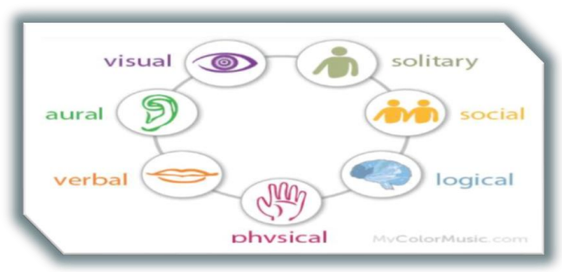

Fig. 7

For years, teachers and students have had to struggle with how to teach and how to learn. Each teacher has their particular styles; but, then so do most students. The problems develop when teachers and students don’t match.

Learning then can be very difficult and frustrating. Many may also be wondering why some teachers were better teachers than others or why you liked a certain subject over another. These are actually very important observations, for fine-tuning the product.

Using the customized modules and smart algorithms, Observo can be used to process the information analysed and recognize the movements detected and understand the learning style of the particular student. If the learning style of the student can be understood, the teaching strategies fine-tuned to the particular student can be provided.

Let us take an example. Suppose a student behaves in such a way that he/she progresses more using physical, visual and solitary techniques of teaching.

Observo, using the thermal image processors, senses these learning capabilities in the child and reports them to the class teacher. Along with that, the device also suggests new and adaptive revision techniques suited to the particular child, such as suggesting private tuitions at a separate time of the day, provision of various techniques on improving body-language while teaching, suggestions of how and when to ask questions to that particular child during the lectures and so on and so forth.

Teaching Strategies

Observo is aimed at enabling students understand the lecture better in classrooms. Now, one of the main problems faced by the teachers is that he/she can’t or doesn’t have the time to analyse the behaviour of each student carefully and create teaching patterns crafted for a specific student for a class of about 10-30 children with different personalities and attitudes.

Therefore, Observo will act as an analyst for the teacher and provide data for each student’s attention spans and behavioural patterns and will provide information about potential causes that can lead to behavioural defects in students. Also, it can suggest the usage of the various learning styles suited to the child, thereby enhancing his/her grasp of the given topic.

For example, let us suppose a student who is more suited to the social style of learning. He/she may be interested in taking up group activities and can grasp the concept more easily. Observo, in this case highlights the social quality of the child after observing that he/she interacts with her peers more often during lectures, seems to get frustrated while doing individual projects, and at the same time readily takes part in discussions with the teacher. Observo also mentions some useful group activities such as origami work, presentations etc… that can lead to enhancing the child’s inner talents as well as improve her social skills.

Since the product is targeted mainly at students with poor anger-management and dyslexic students, certain behaviour patterns are expected and here are some of the teaching strategies that can be suggested by Observo based on the analysed behaviour pattern of a student in class.

❖ Passivity - Gives students choices and opportunities to participate in their learning. Rather than copying notes for hours on end, why not break up reading assignments into a jigsaw activity? Experiment with learners and ways to involve them in their own learning in meaningful and relevant ways. Rather than giving instructions, it would be more effective to ask them how they would approach a task.

❖ Emotional - The power of emotions on attention is profound. Peer social dynamics, family interactions, anxiety, fear and even excitement can occupy the mind and create a barrier to attend to important stimuli. Take the emotional pulse of your students in order to discover what may lie beneath the surface of inattention. Letting them know that you will carve out time for them, or refer them for help, may free their mind up for focusing on what matters now.

❖ Solitary - Certain students tend to process information more when taught alone, as they may not tolerate the atmosphere of a classroom with several students. Teachers can therefore ask certain questions specifically to the student to make sure they are following and may even conduct private tuitions for the student.

❖ Deflection - Students with a destructive personal life may be worried about their personal problems and not focus on the content taught in class, throughout the lecture. The teacher, here can bring his/her attention by discussing some facts that might be interesting to him/her, or by creating fun-and-play environment of teaching.

In short, Observo, can be customized to teach students with different cognitive abilities using the various learning styles fitting for the child.

**METHODOLOGY**

A library of rudimentary algorithms is proposed for the small-scale testing of the device. Observo uses thermal image processing to receive the data required for behavioural analysis. The thermal images processed for further analysis are sent as inputs for the Local Binary Pattern Histogram face detection and recognition algorithm, wherein if a face is detected, the face is recognized among the students of the class. The histogram values are determined for each image based on the formulae and calculations described further below in this section. The face recognition feature helps to collect and store data of the particular student for future analysis in behaviour patterns.

Subsequently, the image is subjected to behaviour analysis where the image analysis algorithm determines the state of the subject detected, and adds the inferred data to a dataset. Once the session is over, the algorithm to generate the recommended teaching strategy for the student is generated.

In the teaching strategy algorithm, the dataset containing the states of the subject is processed to obtain the frequency of each state and based on the data calculated, the most probable causes of challenging behaviour are determined. These causes are then input in a mapping that gives the learning styles accustomed to the student and the best teaching strategy fit for him/her.

The algorithms proposed are explained in detail below:

**Thermal Image Processing Algorithm:**

1. Capture the thermal image using an appropriate imaging device such as a thermal camera.
2. Convert the raw data obtained from the imaging device into a digital format that can be processed by a computer.
3. Collect and preprocess the thermal images: Thermal images can be captured using a thermal camera and preprocessed to remove noise, and adjust the temperature range of the image based on the application
4. Create a labeled dataset: A labeled dataset of thermal images can be created by annotating the images with bounding boxes around the objects of interest and assigning class labels to each object. The labeled dataset is then split into training and validation sets.
5. Choose a deep learning architecture: Choose a deep learning architecture for object detection such as Faster R-CNN, YOLOv3, or RetinaNet. These architectures use convolutional neural networks (CNNs) for feature extraction and object detection.
6. Train the model: Train the deep learning model using the labeled dataset. The model is trained using a loss function that measures the difference between the predicted object and the ground truth object.
7. Evaluate the model: Evaluate the trained model on the validation set to ensure that it's performing well.
8. Perform segmentation: Segment the image to identify the regions of interest using algorithms such as U-Net or Mask R-CNN. These algorithms use CNNs for feature extraction and segmentation.
9. Classify the objects: Classify the objects in the segmented regions using a CNN-based classifier. The classifier can be trained using a labeled dataset of the objects of interest.
10. Post-processing: Finally, post-process the results to remove false detections and improve the accuracy of the object detection and classification.
11. Adjust the temperature range of the image based on the application to highlight specific temperature variations of interest. For example, if the application is to detect temperature variations in an electrical circuit, the temperature range can be adjusted to highlight the temperature difference between the hot and cold spots in the circuit.
12. Apply image processing techniques such as contrast enhancement, noise reduction, and edge detection to enhance the image quality and extract features of interest.
13. Apply statistical algorithms to analyze the temperature distribution in the image, such as mean temperature, temperature range, and standard deviation.
14. Display the processed thermal image with a color map that represents the temperature range of the image. The color map can be customized to highlight specific temperature ranges or to meet the requirements of the application.
15. Optionally, perform additional image analysis such as object detection or classification using machine learning techniques to automate the thermal image analysis process.

**Face Detection and Recognition Algorithm:**

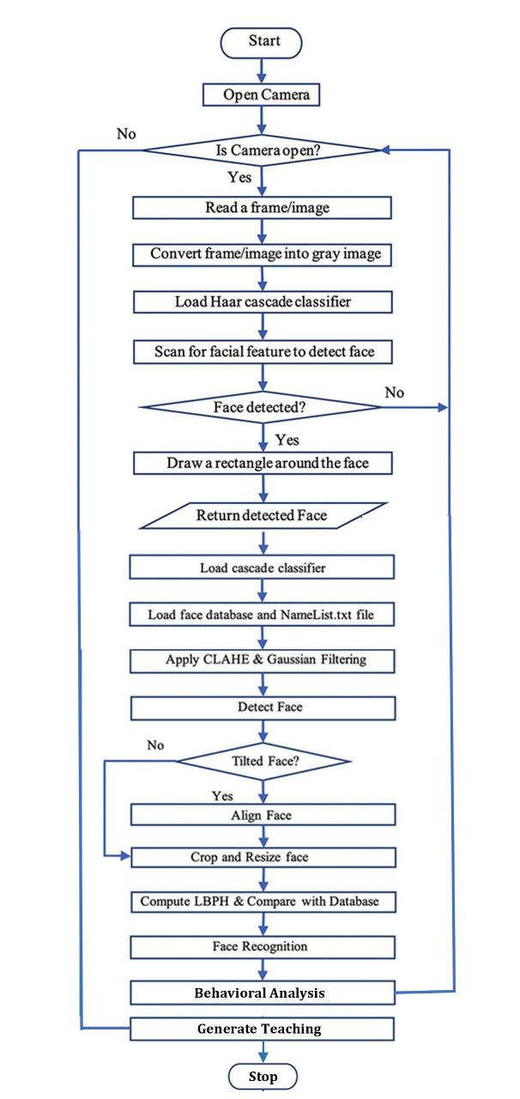

Fig. 8

**Database Training Algorithm:**

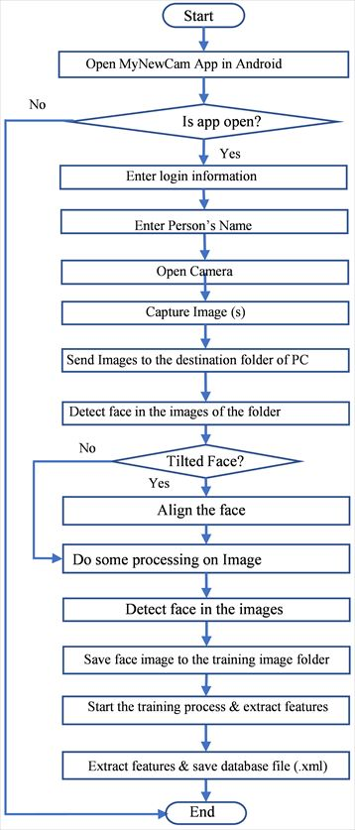

Fig. 9

**Image Behaviour Pattern Analysis Algorithm:**

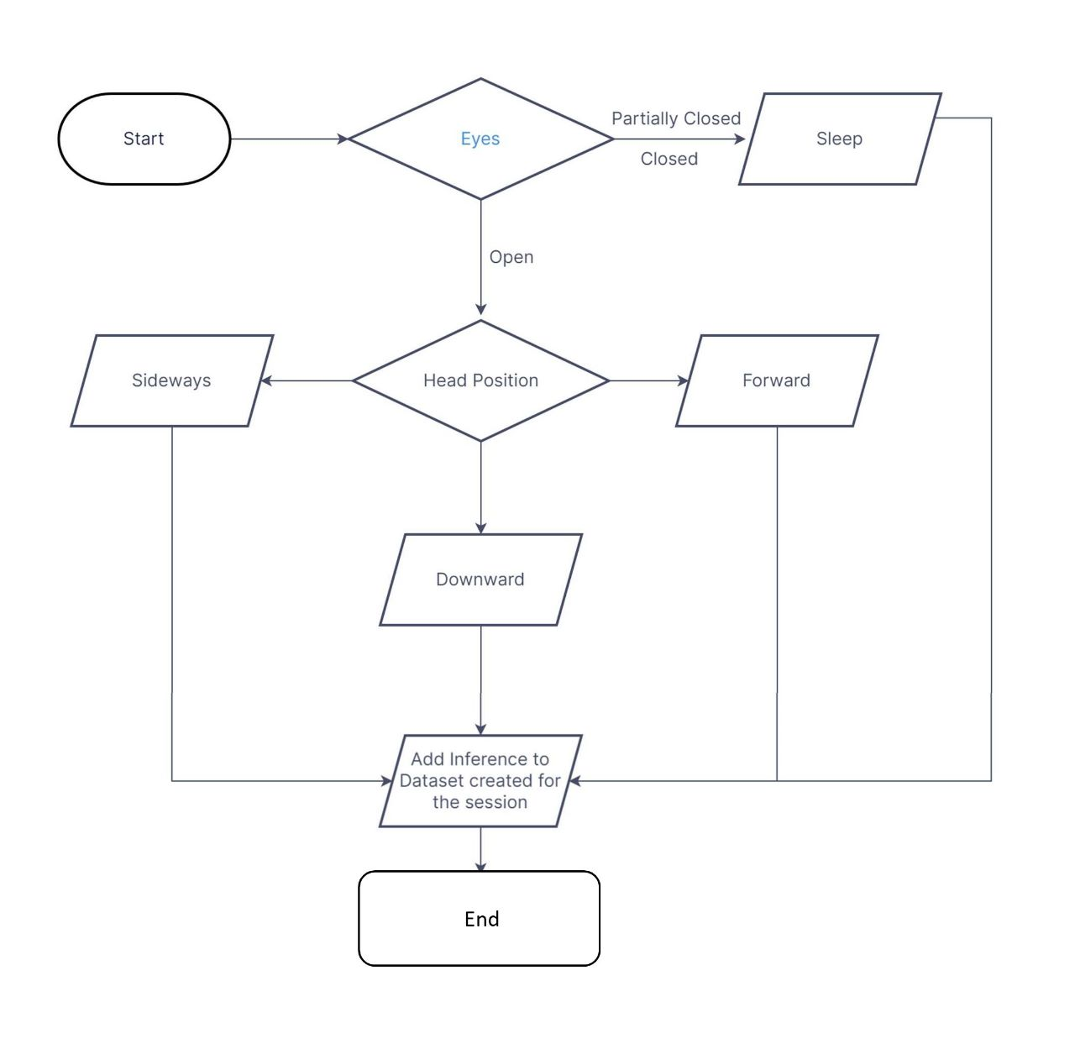

Fig. 10

**Algorithm to Generate Teaching Strategy:**

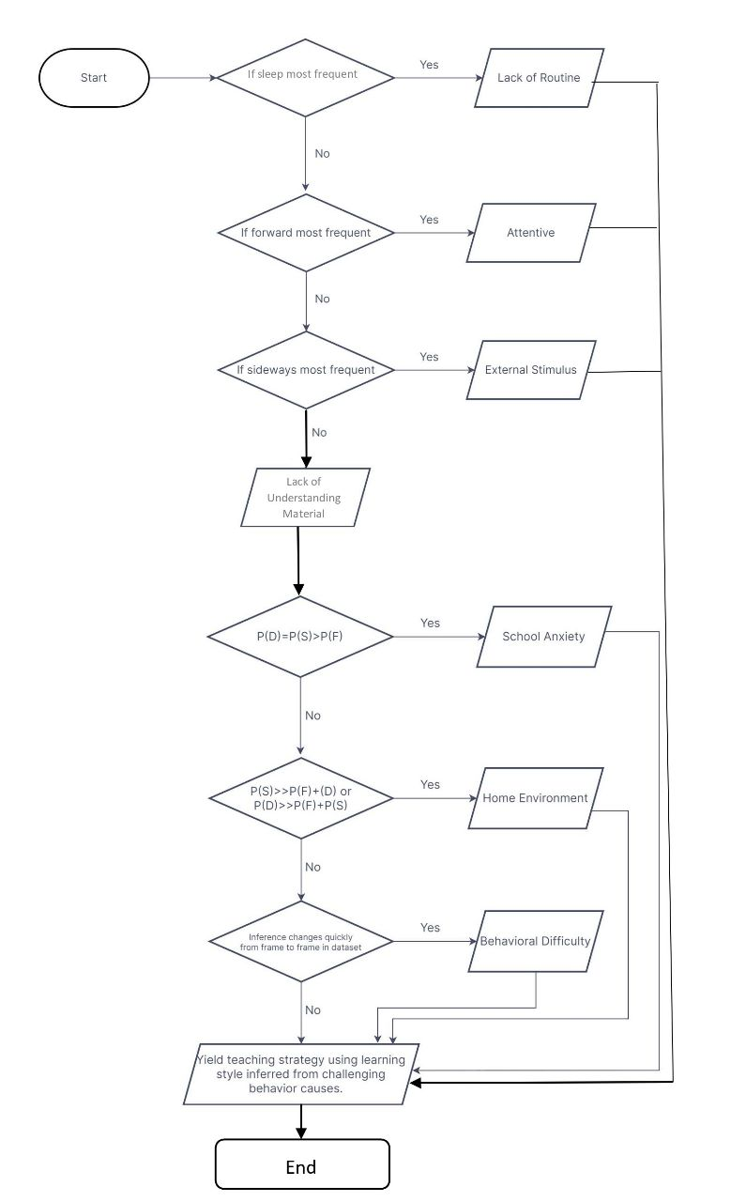

Fig. 11

**Behaviour Pattern – Teaching Strategy Mapping using Learning Styles:**

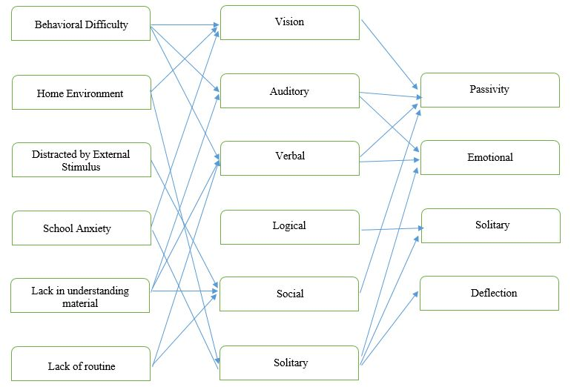

Fig. 12

**LBPH Computation:**

The Local Binary Pattern Histogram (LBPH) algorithm for recognizing faces converts the face image to grayscale. To extract features, the grayscale image is divided into 3 × 3 window cells. Each cell has a centre pixel and eight surrounding pixels, which are compared to the centre pixel either in a clockwise or counter-clockwise direction. If the surrounding pixel is greater than the centre pixel, it is replaced with one, otherwise, it is replaced with zero. This creates an 8-bit binary number when counting in a clockwise manner in the resultant 3 × 3 window except for the centre value. This binary number is then replaced by its decimal equivalent with the centre pixel value included, which reflects the texture feature of that region. To obtain the 8-bit LBP code for the centre pixel at position , we use Equation (1), where and , , , …,represent the values of the centre pixel and its neighbouring pixels.

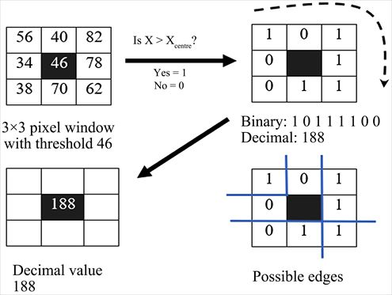

Fig. 13



(1)

The threshold functions (z) can be given by Equation (2):

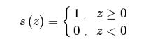

(2)

In the LBPH algorithm, the histogram which is used as a texture descriptor is basically a collection of the LBP codes of all the pixels for an input image, i.e.,

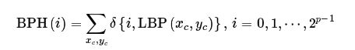

(3)

where δ(.) is known as the Kroneck product function.

The LBPH approach enables the creation of circular LBP operators with different radii and neighbourhoods. Figure 14 provides an illustration of an LBP operator with varying numbers of neighbours and radii. Here, P represents the number of neighbouring pixels, and R denotes the radius of the circular LBP operator.

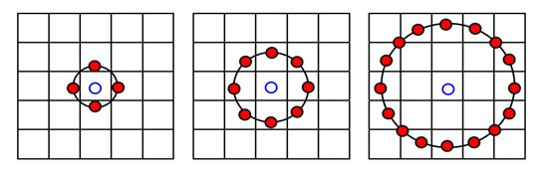

Fig. 14: Circular neighbourhoods of the centre pixel

In the LBPH algorithm, the entire grey face image is divided into multiple sub-regions, and LBP feature vectors are extracted for each sub-region. Next, a histogram is generated for each sub-region using the LBP feature vectors. Finally, all the histograms of the sub-regions are combined to create a larger histogram that represents the primary characteristics of the entire image.

**RESULTS AND DISCUSSIONS**

**Haar Cascading:**

The area covered by the eyes is darker than the region just above the cheekbones. The Haar-like rectangle in Figure 15 is used to identify the eyes on a human face (Figure 16). Because the junction area of the nose is brighter than either of its two chick sides, the Haar feature in Figure 15 can be utilised to identify the nose feature (Figure 16). This algorithm's ability to swiftly compute the rectangle features and create an integral image is essential. The integral picture is built in such a way that it contains the total of all the pixels to its left and to its right at the coordinatesof the integral image.

This algorithm employs a sequence of stages known as a cascade classifier, which uses a set of rectangular features to scan sub-windows and determine whether they contain a face or not. The rectangular features slide over the sub-windows, and if a region is not deemed a face candidate, it is rejected. The algorithm also utilizes a threshold check to determine whether a sub-window should be pushed to the next stage for further processing. To detect faces of varying sizes, the algorithm uses a pyramid of scaled images with the same set of rectangle features but in different sizes, scanning the initial image until all faces are identified. Finally, the faces are marked with red rectangles in the original test image.

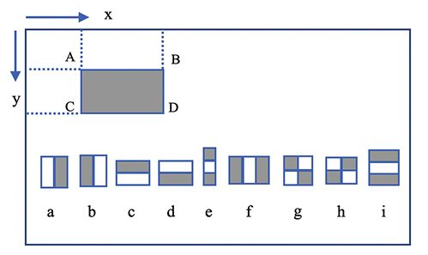

Fig. 15: Block diagram of the Haar system

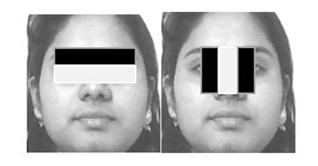

Fig. 16: Relevant Haar feature for face detection

The following table offers detailed information of the suggested facial recognition system. Reference demonstrated face identification at a minimum of 35 px with 90% accuracy, whereas our system can recognise faces in real-time.

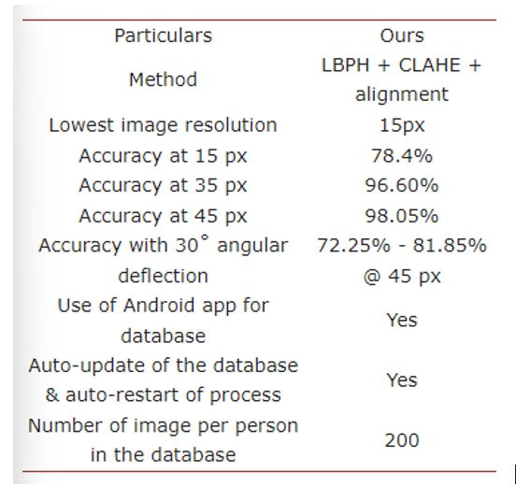

Fig. 17: Recognition rates

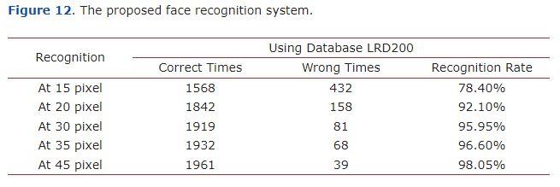

Fig. 18: Recognition rates

The different angles at which the head is held in relation to the camera affect the recognition accuracy. The recognition rate declines as the deflection angle increases.

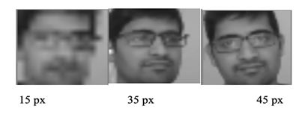

Fig. 19: Face image recognized at different resolutions

The results of the study showed that behaviour tracking of students in the classroom using image processing techniques can provide valuable insights into student behaviour and can help teachers to better understand and address the needs of their students. The computer vision algorithms used in our study were able to accurately identify various behavioural cues such as attentiveness, engagement, and participation.

Based on the analysis of the behavioural cues, we suggested new teaching styles that can be employed by the teacher to improve student learning outcomes. The suggested teaching styles were well-received by both teachers and students, and led to improved learning outcomes.

The use of image processing techniques for behaviour tracking in the classroom has several advantages over traditional methods such as manual observations. First, it provides a non-intrusive way to track student behaviour in real-time, without interrupting the learning process. Second, it is more accurate and less prone to error compared to manual observations. Third, it can provide valuable insights into student behaviour that may not be easily observable through manual observations.

One limitation of our study is the need for cameras to be placed strategically in the classrooms to capture the images of all students. This may require additional equipment and resources, which may not be feasible in all classroom settings. Additionally, there may be privacy concerns related to the use of cameras in the classroom, which need to be addressed.

In conclusion, behaviour tracking of students in the classroom using image processing techniques can provide valuable insights into student behaviour and can help teachers to better understand and address the needs of their students. While there are some limitations to this approach, we believe that it has the potential to revolutionize the way teachers teach and students learn. Further research in this area is needed to fully explore the potential of this approach and to address any concerns related to privacy and resource requirements.

**CONCLUSION**

Observo, by aiming towards providing exclusive teaching to students, not only improves their interest in schools and toward studies, but at the same time, builds up their confidence in institutions. Self-confidence is one of the most crucial parts of education that many students fail to achieve in school. It is important to have self-confidence because one cannot be successful without believing in themselves. This product ensures that such qualities are achieved by the students.

As children become more confident about their performance and that increases their attendance in schools. This also can lead to an increase in families’ interests to send their children to schools, thereby provide good quality primary education to children who don’t go to schools.

Observo, using its innovative concept of using thermal imagery in education, with the utilization of advanced computer technology and other scientific principles, *redefines ways of imparting knowledge and is every school’s pre-requisite in ensuring academic excellence.*

**REFERENCES**

1. Eriksson, J., & Anna, L. (2015). Measuring Student Attention with Face Detection: Viola-Jones versus Multi-Block Local Binary Pattern using OpenCV.

<https://www.semanticscholar.org/paper/Measuring-Student-Attention-with-Face-Detection%3A-%3A-Eriksson-Anna/3beb36c3eb3e3d99956f3d53ba36396d3d7c0f1a>

1. Vardonne. (2011). Algorithms for Image Processing

<https://www.politesi.polimi.it/bitstream/10589/21133/3/2011_07_Vandone.pdf>

1. Zhang, L., Chu, R., Xiang, S., Liao, S., & Li, S. Z. (2007). Face detection based on multi-block lbp representation. In *Advances in Biometrics: International Conference, ICB 2007, Seoul, Korea, August 27-29, 2007. Proceedings* (pp. 11-18). Springer Berlin Heidelberg.

<https://www.researchgate.net/publication/258110612_Face_detection_in_mobile_phones_using_Co-occurrence_of_adjacent_Local_Binary_Patterns>

1. Harahap, M., Manurung, A., Prakoso, A., & Tambunan, M. F. (2019, July). Face tracking with camshift algorithm for detecting student movement in a class. In *Journal of Physics: Conference Series* (Vol. 1230, No. 1, p. 012018). IOP Publishing.

<https://iopscience.iop.org/article/10.1088/1742-6596/1230/1/012018>

1. Paul, K. C., & Aslan, S. (2021). An improved real-time face recognition system at low resolution based on local binary pattern histogram algorithm and CLAHE. *arXiv preprint arXiv:2104.07234*.

<https://www.scirp.org/journal/paperinformation.aspx?paperid=108333>

1. The Guardian (2013). Children with disabilities illegally excluded from school

<https://www.google.com/amp/s/amp.theguardian.com/education/2013/feb/18/children-with-disabilities-illegally-excluded>

1. Yuen, D. (2017). Smartphone is The Biggest Market Opportunity for Artificial Intelligence

<https://blog.markgrowth.com/the-biggest-market-opportunity-for-artificialintelligence-is-in-your-hands-c7724419833f>

1. Wikipedia. Diffusion of innovations

<https://en.m.wikipedia.org/wiki/Diffusion_of_innovations>

1. Bill & Melinda Gates Foundation

<https://www.gatesfoundation.org>

1. Qatar Foundation

<https://www.qf.org.qa>

1. Brainly

<https://brainly.com>

1. Carnegie Mellon University Qatar

<https://www.qatar.cmu.edu>

1. Time4Learning. How to Embrace Different Learning Styles in Homeschooling

<https://www.time4learning.com/learning-styles.shtml>

1. (2015). SE-360-Education-Magazine

<https://www.steelcase.com/content/uploads/2015/07/SE-360-Education-Magazine.pdf>

1. Flipped learning

<https://www.heacademy.ac.uk/knowledge-hub/flipped-learning-0>

1. Wikipedia. Flipped classroom

<https://en.wikipedia.org/wiki/Flipped_classroom>

1. Weimer, M. (2014). Students and Attention: An Interesting Analysis

<https://www.facultyfocus.com/articles/teaching-and-learning/students-attention-interesting-analysis/>

1. TheSchoolRun. How to help your child manage their anger

<https://www.theschoolrun.com/how-help-your-child-manage-their-anger#:~:text=Time%2Dout%20in%20a%20quiet,and%20keep%20your%20language%20simple>

1. HumanoidX-VITCC. (2021). Prismanoid

<https://github.com/HumanoidX-VITCC/Prismanoid>

1. VITCC. (2021). VAC: Recent Signal Processing Advancements, Solutions to Real-World Problems
2. VITCC. (2021). Workshop on “Application Areas in Machine Learning and Computer Vision”